**[E R Diagram for Online Shopping System](https://meeraacademy.com/e-r-diagram-for-online-shopping-system/)**

E-R Diagram for Online Shopping Website

E-R diagram means Entity Relationship diagram. Entity means object of system, generally we refer entity as database table , the e-r diagram represent the relationship between each table of database. E-R diagram represent entity with attributes, attributes is a properties of entity. If we assume entity is a database table then all the columns of table are treat as attributes.

* Entities are represented by rectangles.
* Attributes are represented by ellipses.

Online Shopping system E-R Diagram

[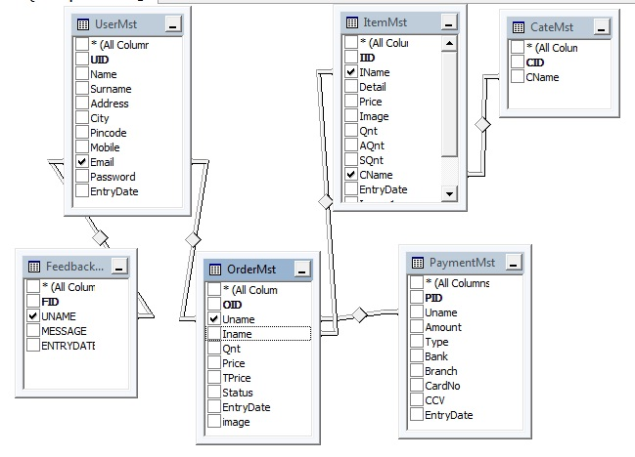](https://www.youtube.com/coderbaba)E-R Diagram for online shopping system project

We also represent E-R  diagram for online shopping system like  :

[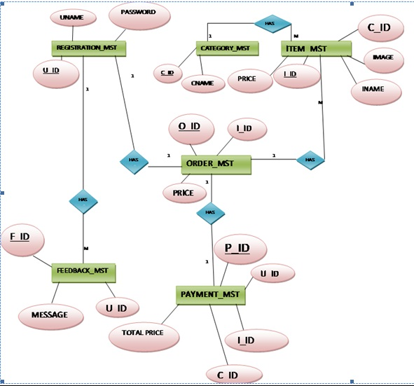](https://www.youtube.com/coderbaba)System flow chart for online shopping website